Project Design Phase-II
Data Flow Diagram & User Stories

Date | 04-10-2026
Team ID | SWTID-2026-1447
Project Name | Import Data using Transform Maps (Spreadsheet)
Maximum Marks | 4 Marks

Data Flow Diagrams:
A Data Flow Diagram (DFD) is a traditional visual representation of the information flows within a system. It shows how data enters and leaves the system, what changes the information, and where data is stored. In this project, employee data flows from the spreadsheet to the Import Set Table, through the Transform Map, into the Employee table, and then into reports and the dashboard.
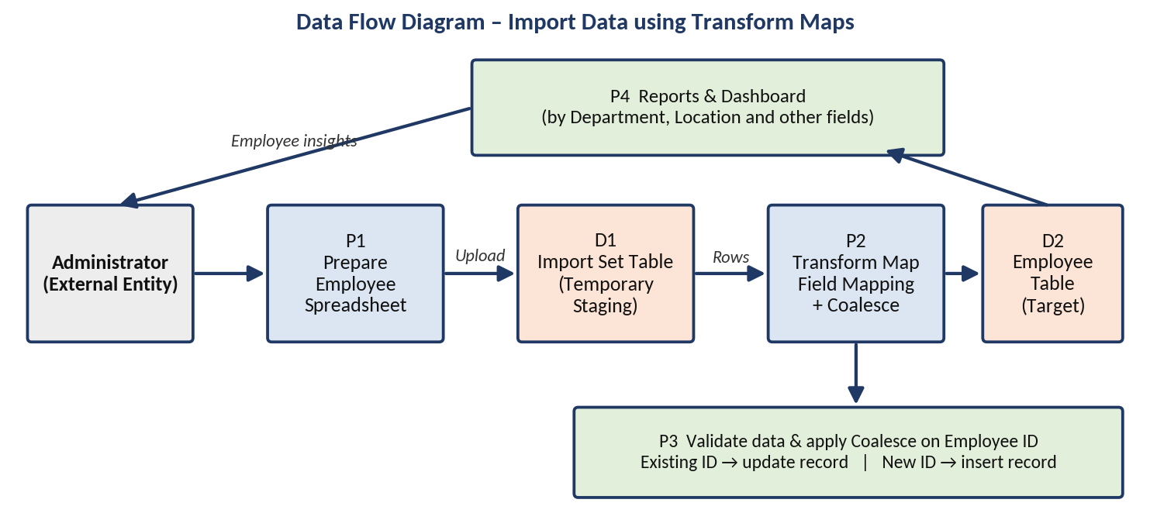
Figure: Data Flow Diagram for importing employee data using Transform Maps
Element | Type | Description
Administrator | External entity | Prepares the spreadsheet and views the reports and dashboard.
P1 – Prepare Employee Spreadsheet | Process | Spreadsheet with Employee ID, Name, Email, Department and Location.
D1 – Import Set Table | Data store | Temporary staging table for the uploaded spreadsheet data.
P2 – Transform Map | Process | Maps Import Set Table fields to the Employee table fields.
P3 – Validate and Coalesce | Process | Validates data; Employee ID decides whether a record is updated or inserted.
D2 – Employee Table | Data store | Target table holding the final employee records.
P4 – Reports and Dashboard | Process | Presents employee data by Department, Location and other fields.

User Stories
The following table lists the user stories for the project.
User Type | Functional Requirement (Epic) | User Story Number | User Story / Task | Acceptance criteria | Priority | Release
Administrator | Spreadsheet and Employee Table Creation | USN-1 | As an administrator, I can create a spreadsheet containing Employee ID, Name, Email, Department and Location so that it can be used as the data source. | The spreadsheet contains all five employee columns | High | Sprint-1
 |  | USN-2 | As an administrator, I can create the Employee table so that imported employee records have a target table. | The Employee table contains fields for the employee details | High | Sprint-1
Administrator | Import Set Table and Transform Map | USN-3 | As an administrator, I can create an Import Set Table so that the uploaded spreadsheet data is stored temporarily before processing. | Uploaded rows appear in the Import Set Table | High | Sprint-1
 |  | USN-4 | As an administrator, I can create a Transform Map so that Import Set Table fields are mapped to the Employee table fields. | Employee ID, Name, Email, Department and Location are mapped to the target fields | High | Sprint-1
Administrator | Transform, Validate and Coalesce | USN-5 | As an administrator, I can transform the imported data so that employee records are stored in the Employee table. | Employee records are available in the Employee table after the transform | High | Sprint-2
 |  | USN-6 | As an administrator, I can validate the imported employee data so that incorrect or incomplete records are identified and corrected. | Employee ID, Name and Email contain valid data | High | Sprint-2
 |  | USN-7 | As an administrator, I can enable Coalesce on Employee ID so that duplicate employee records are avoided. | An existing Employee ID updates the record; a new Employee ID creates a new record | High | Sprint-2
 |  | USN-8 | As an administrator, I can insert new employee data in Excel format and import it. | New employees appear in the Employee table without duplicating existing records | Medium | Sprint-2
Administrator | Reports and Dashboards | USN-9 | As an administrator, I can create reports on employee data based on Department, Location and other relevant fields. | Reports display employee information grouped by the selected field | Medium | Sprint-2
 |  | USN-10 | As an administrator, I can add the reports to a dashboard so that employee information is available in a single view. | The dashboard displays the added reports | Medium | Sprint-2

